How to fix the scaling of the Image
Do not widen the background with the Position X in the Inspector. Instead do this.
Project Settings (gear icon bottom right) Yes, it is on the right and not the left, like most settings are.
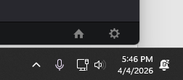
→ Image Scaling

Find:
Input Scaling
Set to:
👉 “Scale full frame with crop”
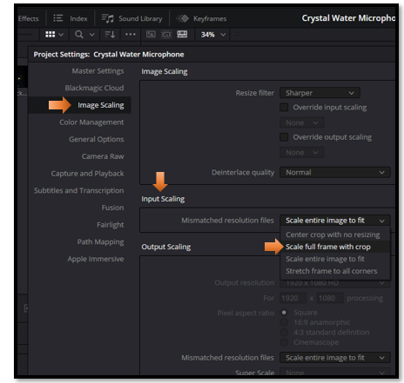
Note-Just because it is cropped, it is not lost. We can still use it when we go to move the window, and this is exactly the behavior that we need.

